PROJECT
ON

YELLOW PAGE FORLUCKNOW

Submitted by:
ANURAG GUPTA
Roll no - 7553005
Group – 61
Under Guidance of
Mr. Vivek Agrawal

in partial fulfillment for the award of the degree
of
BACHELOR OF COMPUTER APPLICATION

SHRI RAMSWAROOP MEMORIAL COLLEGE OF MANAGEMENT
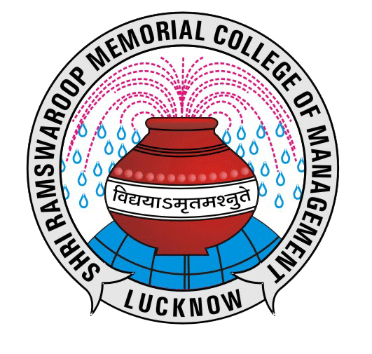
LUCKNOW UNIVERSITY

MAY-2010

TO WHOM SO EVER IT MAY CONCERN

This is to certify that Mr. ANURAG GUPTA, Roll no: 7553005, student of B.C.A. Final year (2007-2010) has completed and submitted his project report on “YELLOW PAGE FOR LUCKNOW” for the fulfillment of B.C.A. Degree.

I WISH HIM ALL THE BEST.

Mr. Vinay Kumar Mishra Mr. Santosh Kumar Dwived (H.O.D. of Computer Application.) (Project Guide)

